Apache Sqoop Installation on Linux

Step 1:-wget https://archive.apache.org/dist/sqoop/1.4.6/sqoop-1.4.6.bin__hadoop-2.0.4-alpha.tar.gz
Command :-wget
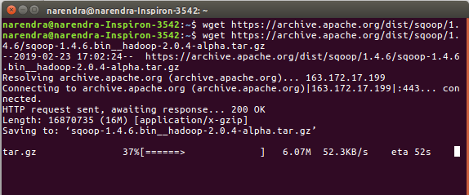
Step 2:- Extract the sqoop tar File.
Command :- ls
Coammnad :-tar -xvzf sqoop-1.4.6.bin_hadoop-2.0.4-alpha.tar.gz

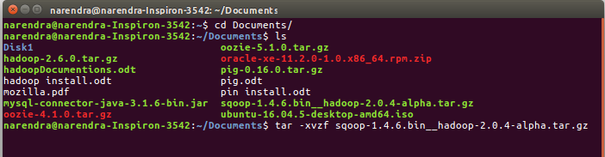
Step 3:-sqoop-1.4.6 file move file /usr/local/sqoop

Command :- sudo mv sqoop-1.4.6 /usr/local/sqoop

Step 4:-Add the sqoop and Java paths in the bash file (.bashrc).
Open. bashrc file. Now, add Hadoop and Java Path as shown below

Command :- gedit ~/.bashrc

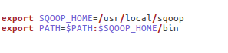

Command :- source ~/.bashrc
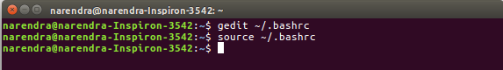
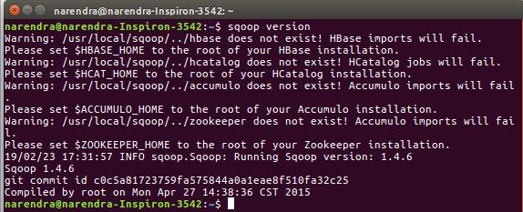
Step 5:- sqoop version: -1.4.6
Command :- sqoop version

Step 6 :- mysql-connector-java-3.1.6-bin.jar download
copy to file sqoop /usr/local/sqoop/lib

Command :-sudo cp mysql-connector-java-3.1.6-bin.jar /usr/local/sqoop/lib

